

Practices for Secure Software Report

Table of Contents
Document Revision History 3
Client 3
Instructions 3
Developer 4
1. Algorithm Cipher 4
2. Certificate Generation 4
3. Deploy Cipher 4
4. Secure Communications 4
5. Secondary Testing 4
6. Functional Testing 4
7. Summary 4
8. Industry Standard Best Practices 4

Document Revision History

Version | Date | Author | Comments
1.0 | 4/18/26 | Dominic Rodriguez

Client



Instructions

Submit this completed practices for secure software report. Replace the bracketed text with the relevant information. You must document your process for writing secure communications and refactoring code that complies with software security testing protocols.

- Respond to the steps outlined below and include your findings.
- Respond using your own words. You may also choose to include images or supporting materials. If you include them, make certain to insert them in all the relevant locations in the document.
- Refer to the Project Two Guidelines and Rubric for more detailed instructions about each section of the template.

Developer
Dominic Rodriguez

Algorithm Cipher

For this scenario, the recommended encryption algorithm would be AES-256 because it is the industry standard. This encryption algorithm is used for protecting sensitive data, offers high efficiency, resistance against brute-force attacks, and speed in software and hardware implementations. SHA-256 should be used for verification to ensure data is not tampered with. This encryption algorithm provides maximum security because it uses a 256-bit key to encrypt data in 128-but blocks over 14 rounds. AES-256 uses secure random numbers that are generated to prevent cryptographic attacks and ensures unpredictability.

Certificate Generation
Insert a screenshot below of the CER file.

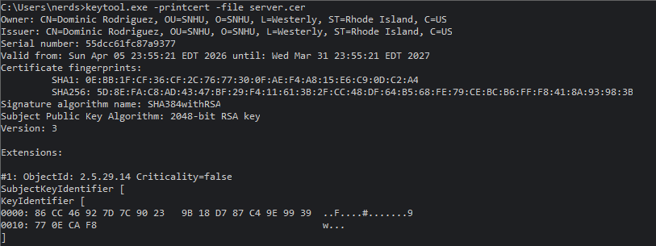

Deploy Cipher
Insert a screenshot below of the checksum verification.

[Insert screenshots here.]

Secure Communications
Insert a screenshot below of the web browser that shows a secure webpage.

[Insert screenshots here.]

Secondary Testing
Insert screenshots below of the refactored code executed without errors and the dependency-check report.
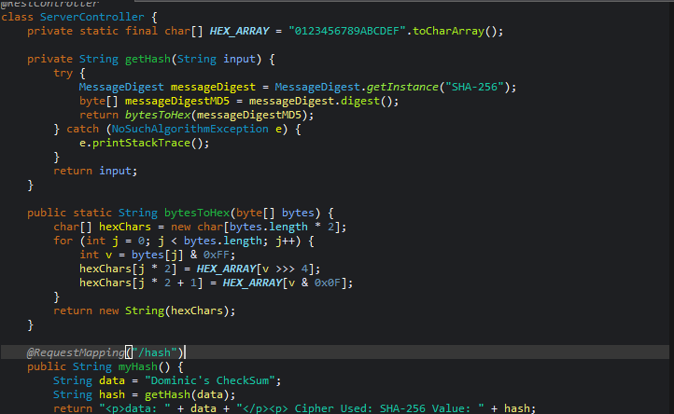
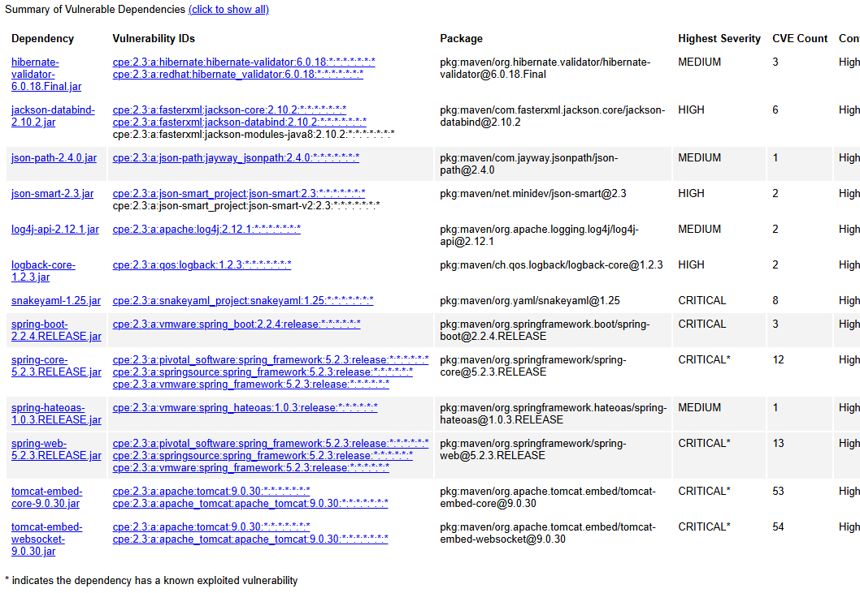

Functional Testing
Insert a screenshot below of the refactored code executed without errors.

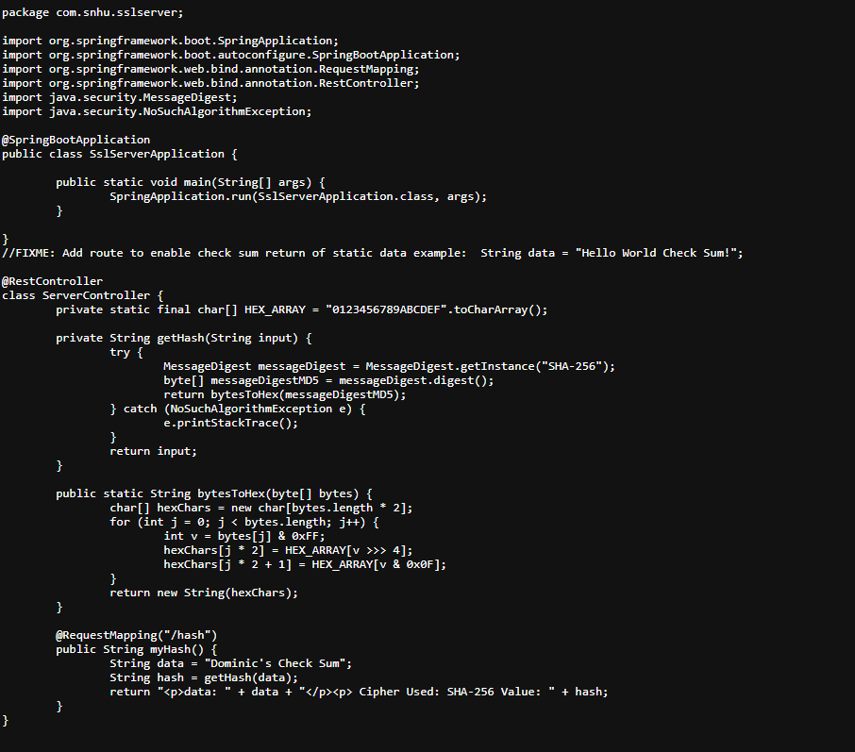

Summary

I chose to work with the SHA-256 cipher because it is the most secure and has a very small chance of running into problems. For the future I would recommend maintaining security of the software by updating security to the most up to date systems while performing checks of the application monthly to ensure sensitive data is kept secure.

Industry Standard Best Practices

I used industry standard best practices to maintain the software application’s existing security by enforcing strict input validation. Existing security is maintained by automated vulnerability scanning, regular management, and secure coding reviews.

